Introduction:
This tool is design to provide solution for configuration analysis. This tool is targeted to reduce human effort to analyze configuration settings. User can change in configuration and verify the changes in actual application by “Apply Changes”.
How to Use:
- Clone the “Solution-App-Configurations” repository.
- Paste “AppConfigSettings” and “AppConfigSolution” files in root folder.
- Keep AppConfig files along with your default page (start page).
- Add snippet code to “bootStrapper” file at the top.
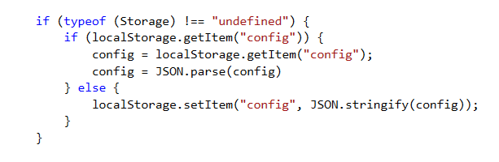
- Set “AppConfigSolution” as start page.
- Run the tool.

-x- Happy Coding -x-

